**MY BUGS ( www.luxeroad-services.fr)**

**Bug 1 - On ipad 3/4 air mini V2 (2048x1536) retina display IOS version 11.0.3 (css)**

Browsers Firefox & Safari -

.a1, .a2, .a3, .a4 display on top of .a5 when it should be underneath

Solution tried- stylesheet line 120 z-index set at -2 and stylesheet line 192 z-index set at -1 but it doesn't help.

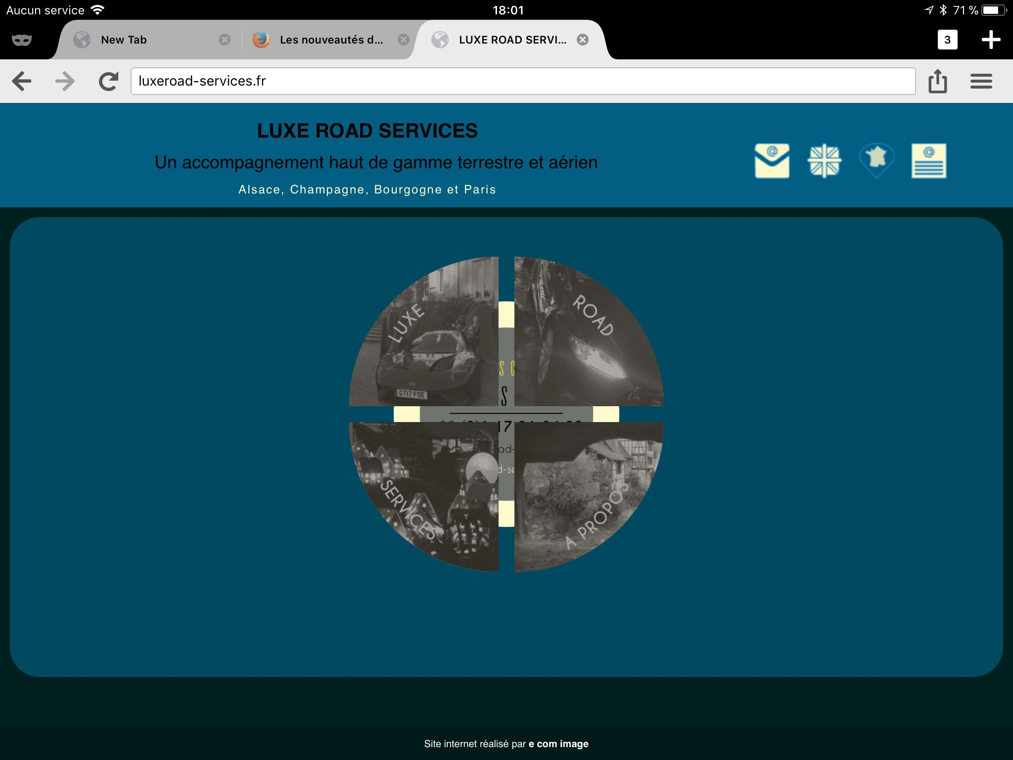



*with bug how it should be*

**Bug 2 - On iMac IOS version 11.0.3 (js)**

Browser Safari - hover function on child element, toggleClass doesn't switch background image (cover.jpg) to background colour rgba(0, 135, 194, 0.4)

<script><!--hover radial menu background changes from image to plain colour -->

$('.accueil2 > .wrap').hover(function(){

$(this).parent().toggleClass('hover');

})

</script>

no solution tried





*with bug( how it should be*

**Bug 3 - On Mac computer (js)**

Browser Firefox - click function on div .a5, toggleClass doesn't flip front image to background image.

<script type="text/javascript"><!--onclick logo flips to back of image -->

$(function(){

$('.a5').click(function(){

$(this).toggleClass('flipMe');

});

});

</script>

no solution tried





*with bug how it should be*

*Note: One of the 2 persons who tried on its Mac computer has that problem but the other doesn't. Weird...*